

**Diploma in Computing (with strands in Software Development & Computer Networks)**

**Level 7**

**(Software Development Strand)**

**DC304 Object-Oriented Analysis and Design**

**Construction Site Attendance Application project**

|  |  |  |
| --- | --- | --- |
| Liana Pak | yib000013o |  |
| Omid Ardakani | Yib00001kq |  |
| Sviatlana Belabarodava | yib00001yl |  |

**Table of Content**

1. Introduction and overview of the project 3

1.1 Introduction 3

1.2 Business Context 3

1.3 Project Description 3

1.4 Goal and objectives of the project 4

1.5 Development Methodology 4

1.6 The target audience and benefit of the information system 4

2. System Requirement Specifications 5

2.1 Functional requirements 5

2.2 Non-functional Requirements 6

3. Functional Model 7

3.1 Use case diagram 7

3.2 Use case specifications 8

3.3 Activity diagrams 10

4. Object Model 12

4.1 Class diagram with attributes and operations 12

4.2 Object diagram 13

5. Logical Design Model 14

5.1 Sequence diagrams 14

5.2 State machine diagrams 21

5.3 Communication diagrams 23

Project Marking Criteria 26

Discussion 29

References 30

# Introduction and overview of the project

## Introduction

Company W is a New Zealand construction organization that is based in Auckland. It constantly has several objects under construction called projects and each of these projects has one or several sites. Employees are daily assigned to the sites depending on their specialization and qualification. Site managers have to track and approve workers’ working hours on a daily basis. After that Project Managers can reject or approve the Timesheet.

## Business Context

The company W is facing a problem of processing all the information described above using paper work. Documentation process includes:

* Attendance form printing out and filling in
* Approval by Site Manager with sending papers by post to the office
* Final Approval by Project Manager

All these issues lead to postpones in salary payment.

## Project Description

The idea of the project is to provide a solution for construction company W for tracking timesheet of workers in hierarchy structure of the company.

This project consists of 3 main modules, including Login, Registration, and Timesheet. The login module for authentication and authorization of users is based on their role in contracture projects. These roles include Project manager, Site manager, Workers, and Admin. Registration module is accessible only by Admin to define and register Project, Site, or Employee and assign roles to them. Timesheet module is accessible by the Site manager to create and approve the Timesheets. The project manager also has accessibility to the Timesheet module to approve or reject timesheets.

The team of developers consists of 3 people and it is estimated that application will be completed in 9 weeks.

## Goal and objectives of the project

**Project Goal**

The main goal of project is to design and implement information system to handle timesheets at distributed construction sites managed by several Site Managers and Project Manager.

**Project Objectives**

* + Eliminate printing out of timesheets and their sending by post from the original timesheet processing
  + Provide Site Manager with user-friendly UI for managing workers’ timesheets
  + Realize two-level approval process for timesheets to make approval process faster and clear
  + Keep information about working hours on specific date at sites/projects in digital format for future report generation and integration with accounting system.

## Development Methodology

As the team is not big (3 people) and the timeframe is short (9 weeks), there was chosen a Kanban methodology as an agile Incremental model which is used when requirements are clearly defined and understood, and there’s a need for early withdrawal of the product to the market.

We organize our work on a Kanban board. The board has stated the columns, which every work item passes through – from left to right. We pull our work items along through the “To do”, “In Progress”, “Testing” and “Done” columns. The only management criteria introduced by Kanban is the so-called “Work In Progress (WIP)”. By visualizing work on a Kanban board and monitoring WIP we could optimize the flow of work and manage the project. We have used Trello for online Kanban board and Git hub as a source control tool to improve team collaboration and manage changes and control versions

## The target audience and benefit of the information system

Project manager and Site manager are the main users of this system. It helps them to monitor and manage their resources and time used in the project at each site. Besides, this system can be developed for integrating with other systems like Financial, Project management and HR system to make automation in many processes.

To achieve the above objective, 3 outcomes will be implemented under this project namely:

1. Reduces the time for processing timesheet.

2. Reduce the human mistake in timesheet processing

3. Improve security of the information of project and insure that the right people access to its.

# System Requirement Specifications

## Functional requirements

The company W wants to have an automated system with the following functional requirements:

* An application realizes a multi-level management of attendance
* Keep information about site and project hierarchy
* Keep general information about workers and daily worked hours.

All functional requirements we will divide to Process Oriented and Information Oriented requirements.

Process Oriented requirements are following:

* Admin has possibility to create/update/delete Users, Sites, Projects
* Site Manager can create / update / approve time records
* Project Manager can approve/reject timesheet

Information Oriented requirements are following:

* For **time record** following information should be kept:

ID of worker who did a job,   
Date on which the job was done   
ID of Site at which job was done   
Working hours which were worked during the day  
Status: status for time record shows whether this record was created and saved, or it is approved by Site and Project Manager.

* For **Site:**Site name   
  Site address   
  ID of manager of the site   
  ID of project, to which this site belongs
* For **Project**name of the project

Address of the project   
ID of manager

* For **employee**Name   
  Surname   
  Contact information  
  Role: role of employee means a position of employee, it can be Admin, worker, Site Manager, Project Manager.

## 2.2 Non-functional Requirements

During our communication with the customer representatives, our company had found out that W also needs an application that can (non-functional requirements):

o Handle at least 6 projects with 6 sites and 50 workers

Regarding to the size of company with looking to feature grown the scaling of the system should be enough for tracking timesheet of almost 50 workers in 6 sites and projects

o High availability and robust system:

Because of that there is no IT support in construction site the client expects that the system works well with lowest level of maintenance and support

o Security of information:

The timesheet information is critical, because the expenses of project and wages of workers will be calculated based on it. The customer expects that the system should insure that the right person can access to the information.

o Have a user friendly and simple UI.

Working in contraction site is quite hard and the system must provide convenience for site managers and reduce their complexity of their process.

# Functional Model

# Use case diagram

The diagram displays the interactions of users and system

A close up of a map

Description generated with high confidence

# Use case specifications

These specifications are formed to capture the users’ fundamental needs within the system. They are formed based on Use case diagram for capturing functional requirements of the system.

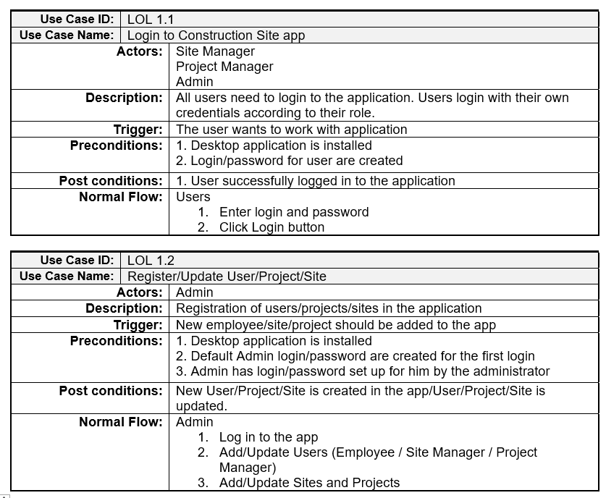

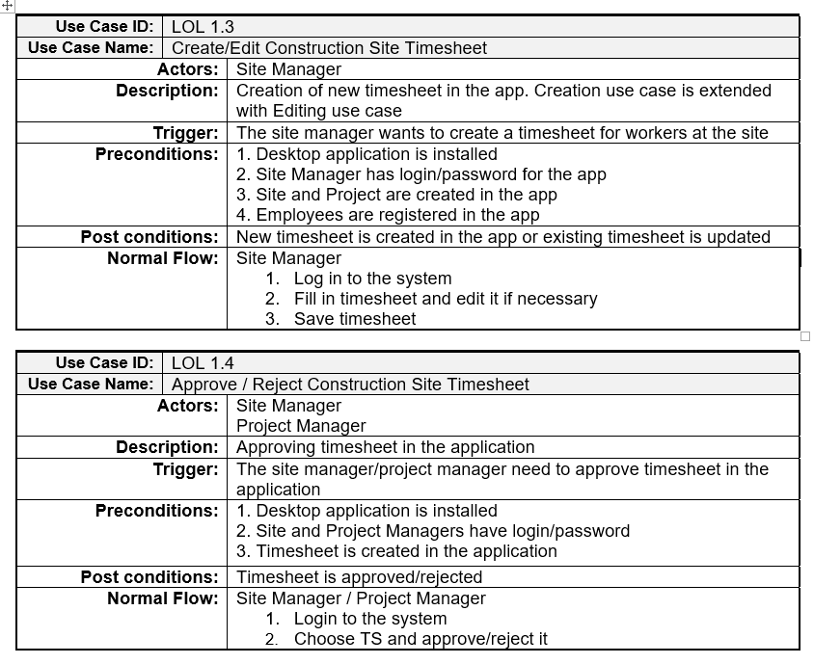

# Activity diagrams

These diagrams are showing the dynamic nature of the system by passing messages and showing the user different options to act.

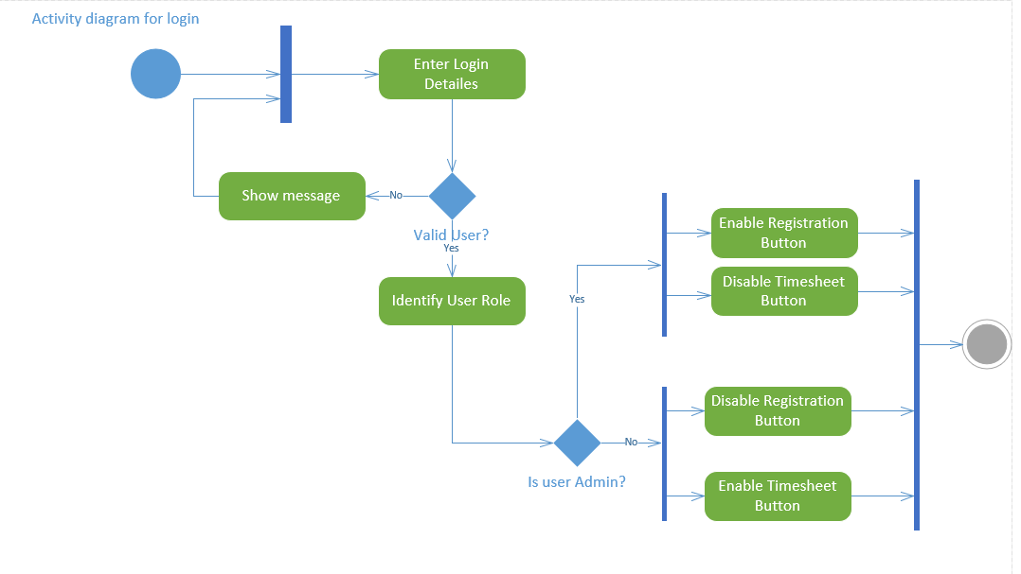

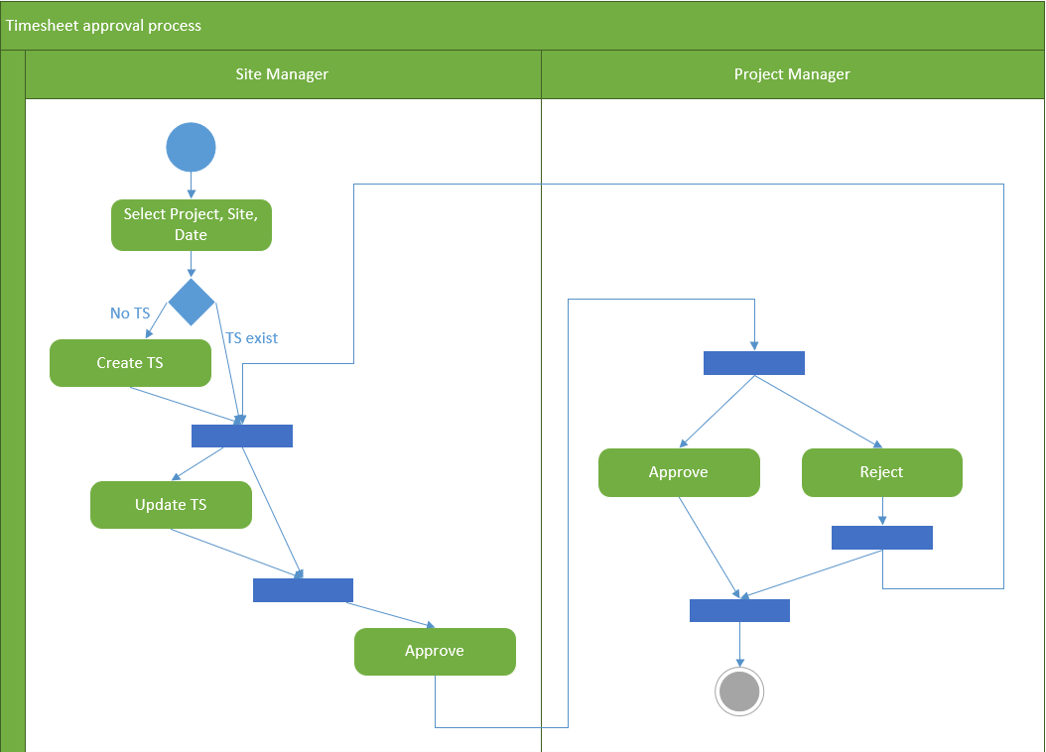

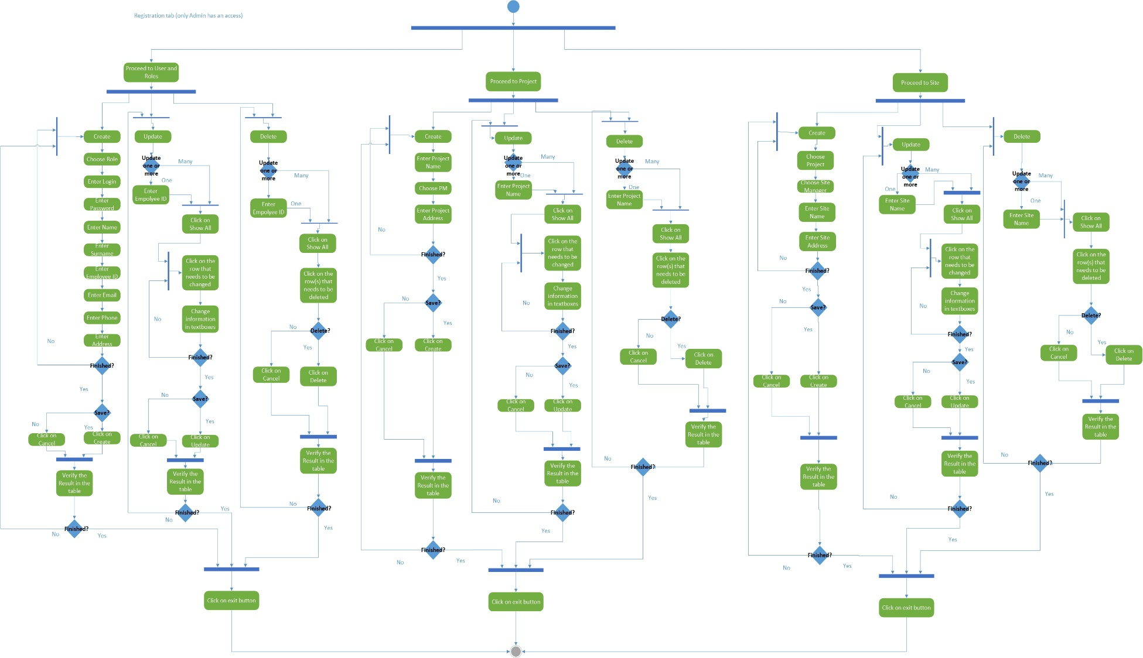

# Object Model

# Class diagram with attributes and operations

Class diagram is used for modelling the system for further coding, understanding the classes, attributes, methods and their interconnection.

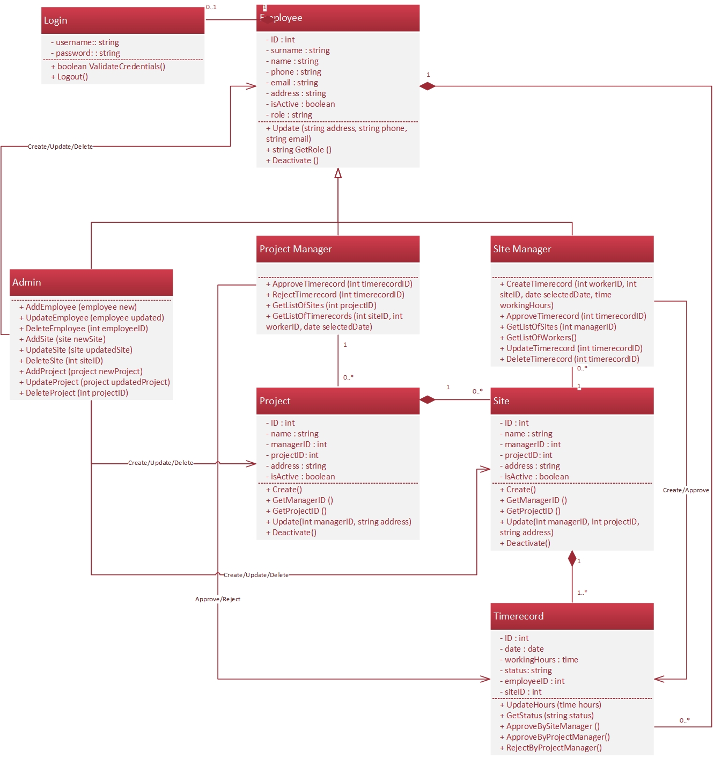

# Object diagram

The diagram is used for modelling the system for further coding, understanding the objects and their interconnection.

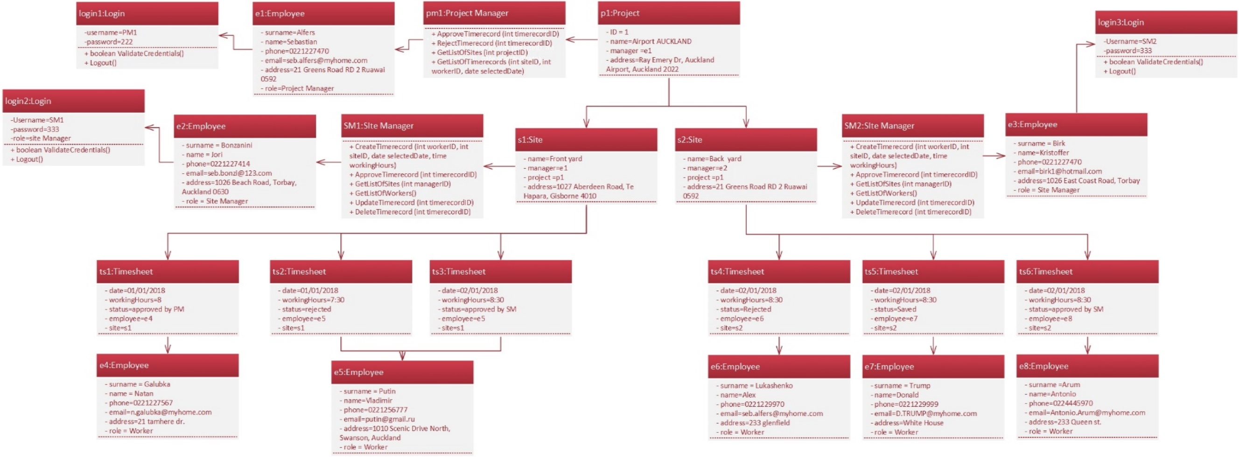

# Logical Design Model

# Sequence diagrams

This type of diagram is showing how the objects interact in time sequence.

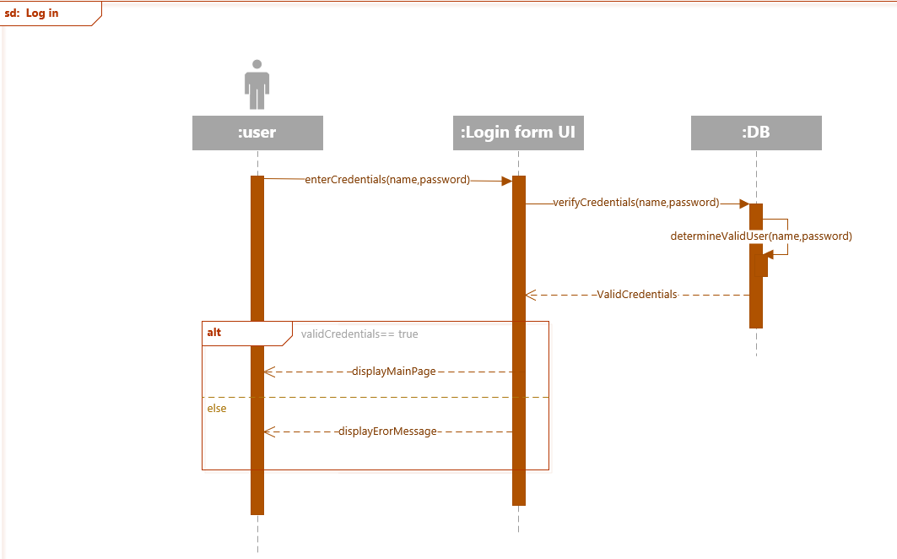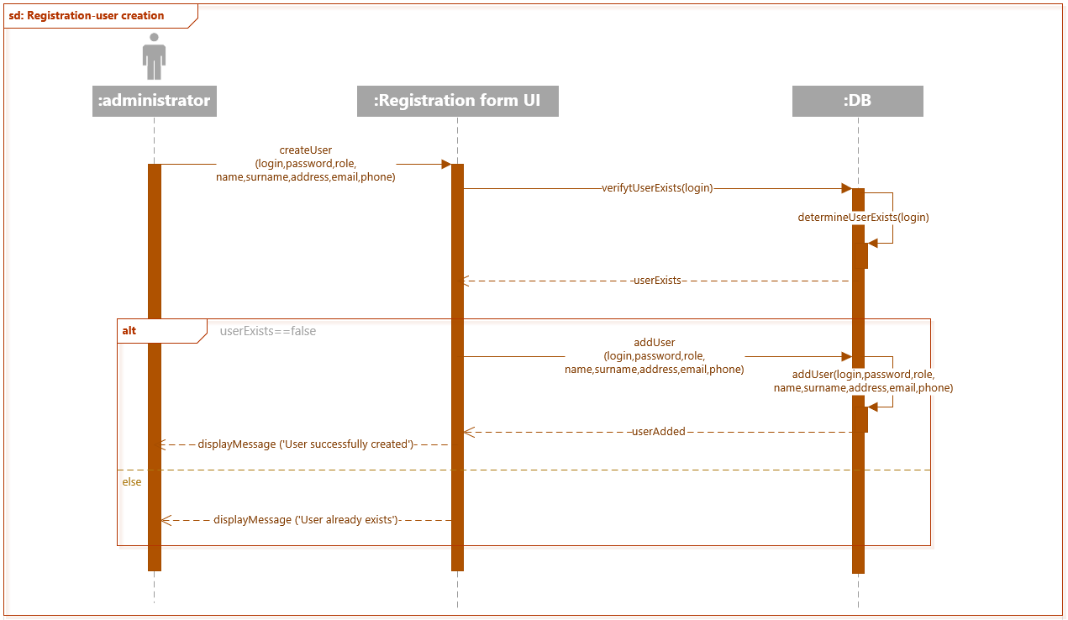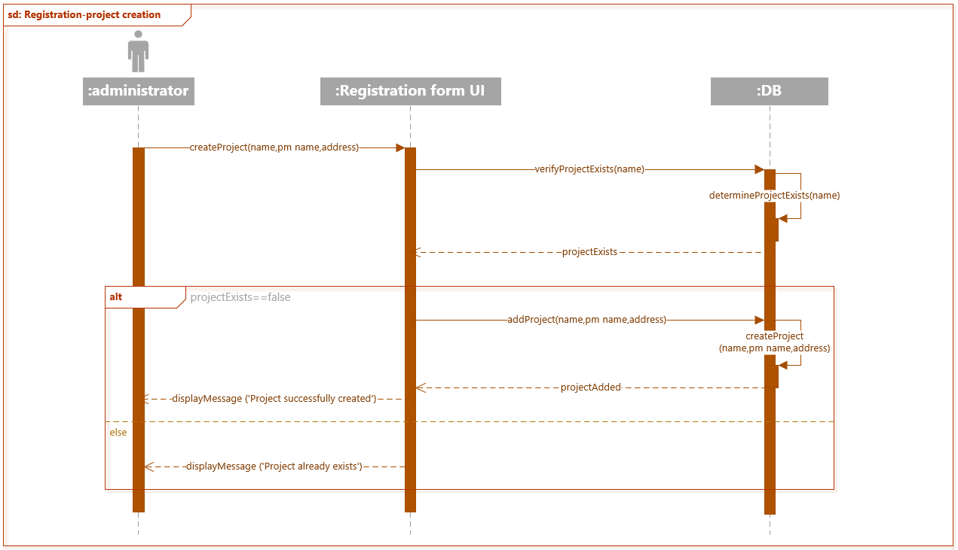

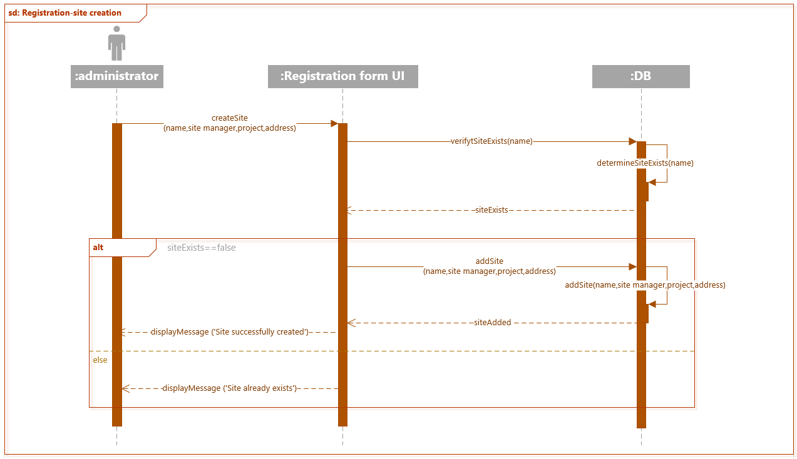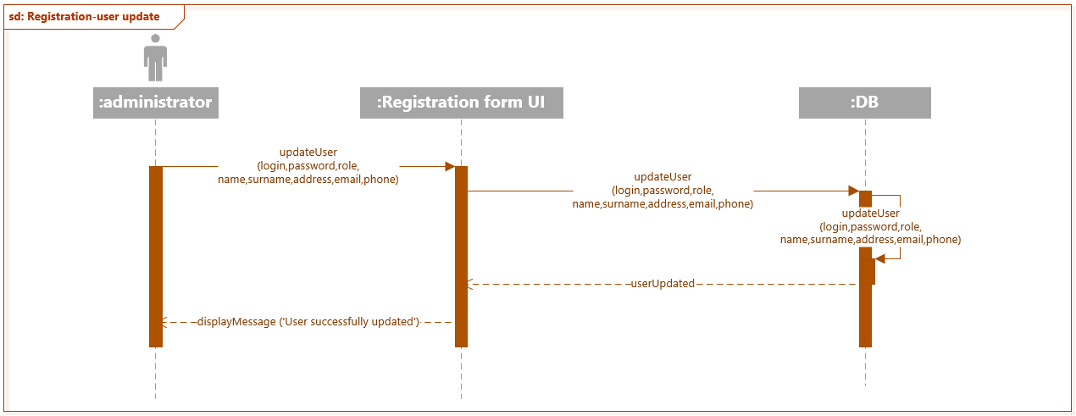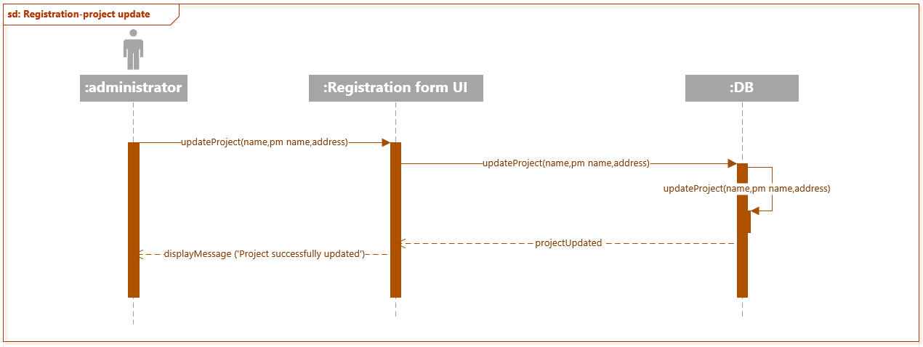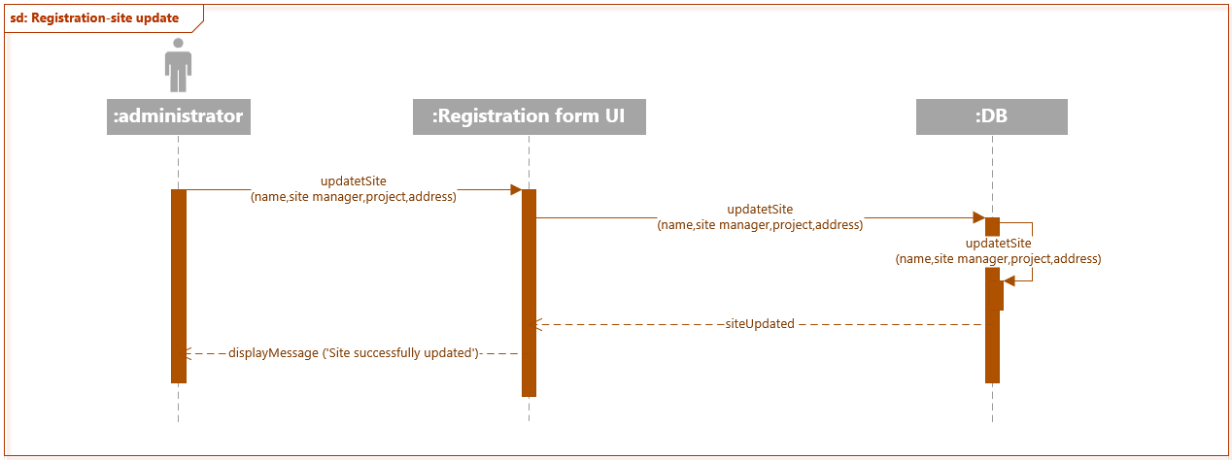

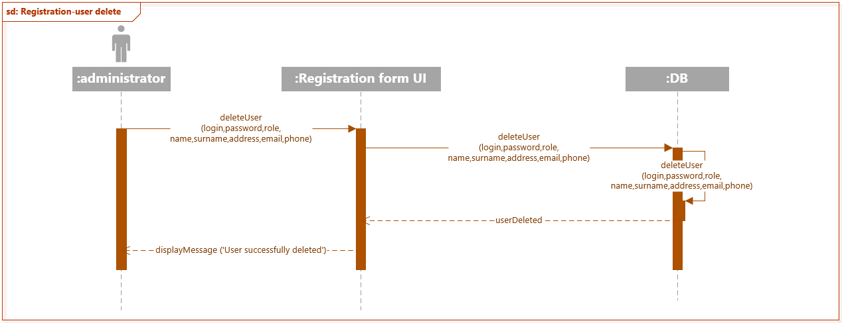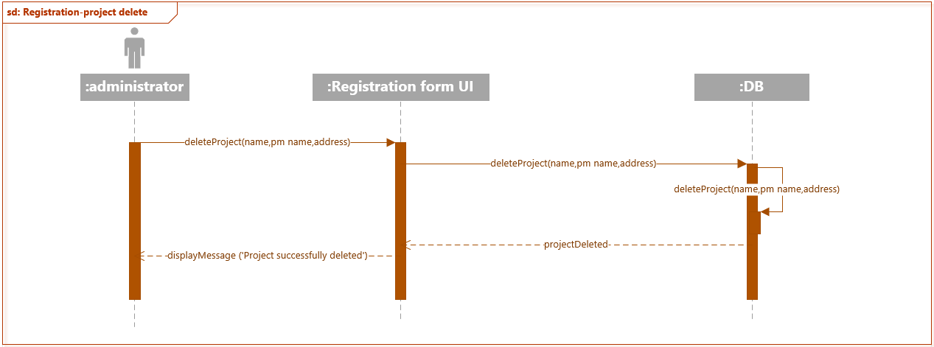

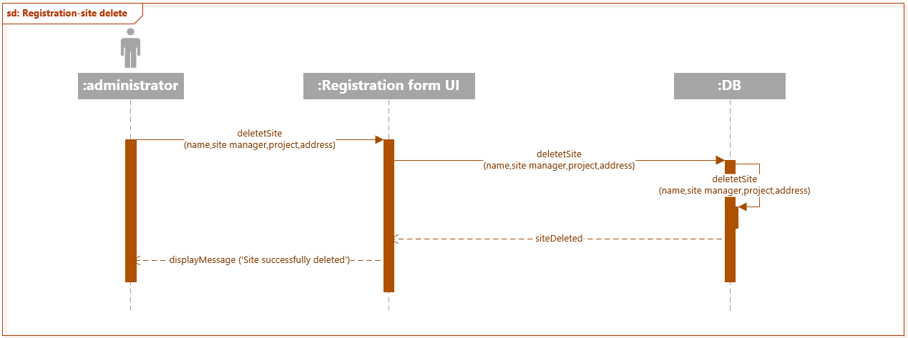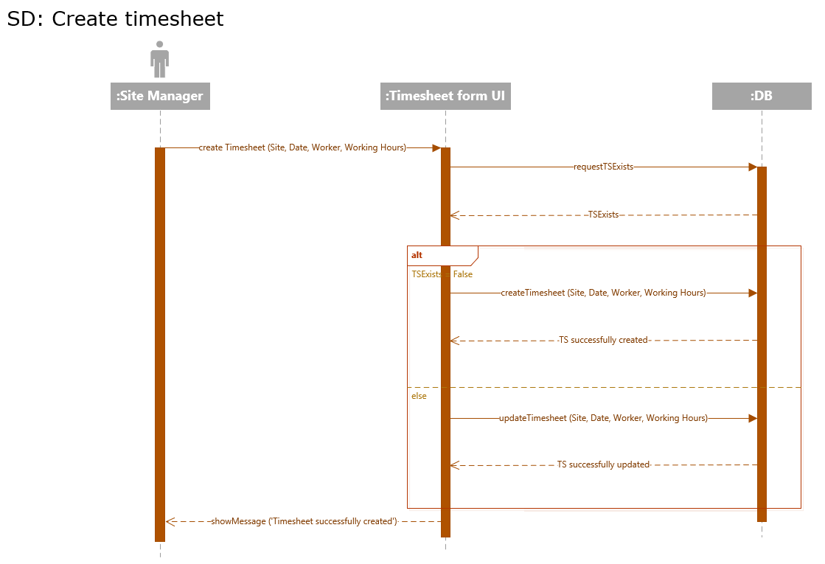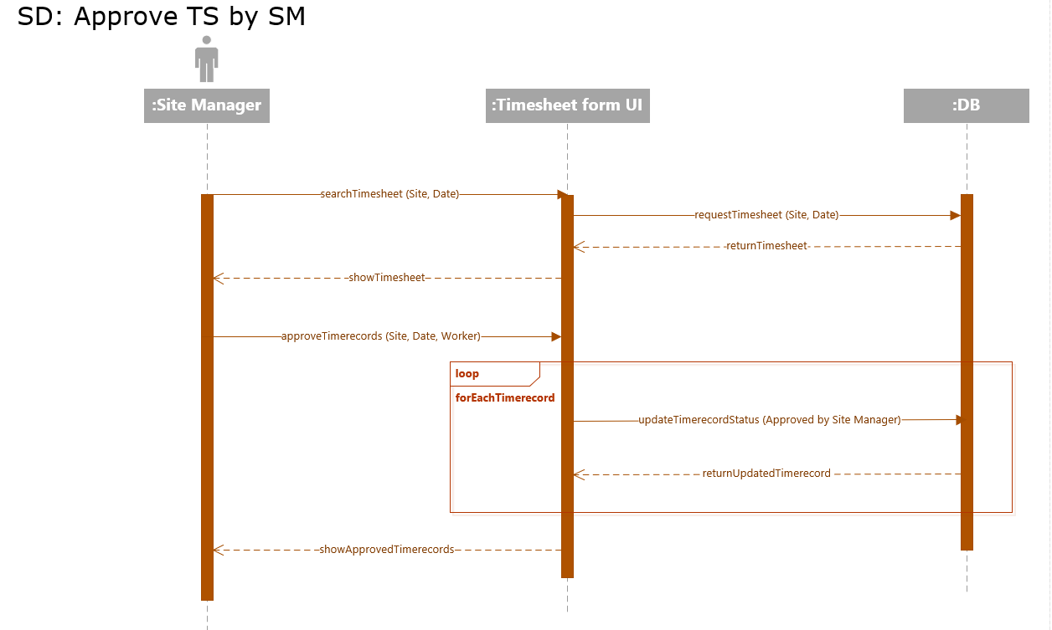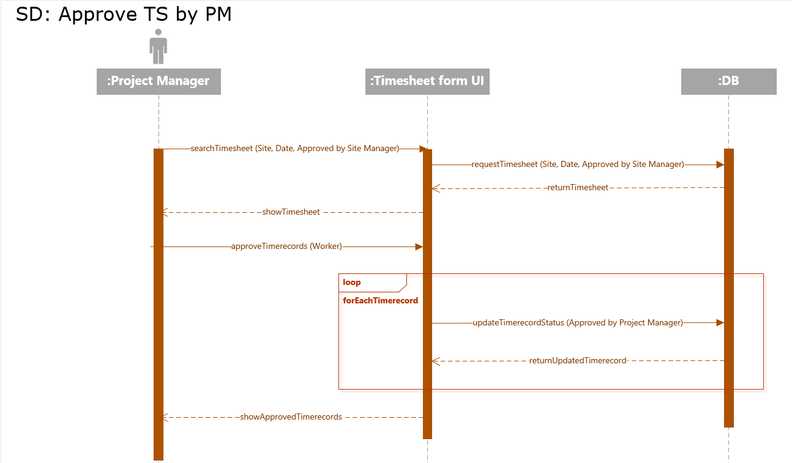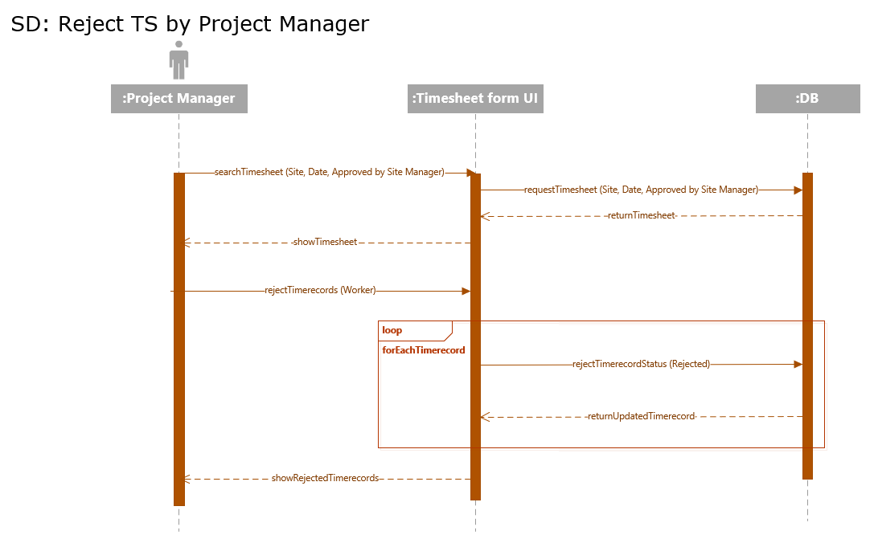

# State machine diagrams

The diagrams are showing different variations of events that an object goes through.

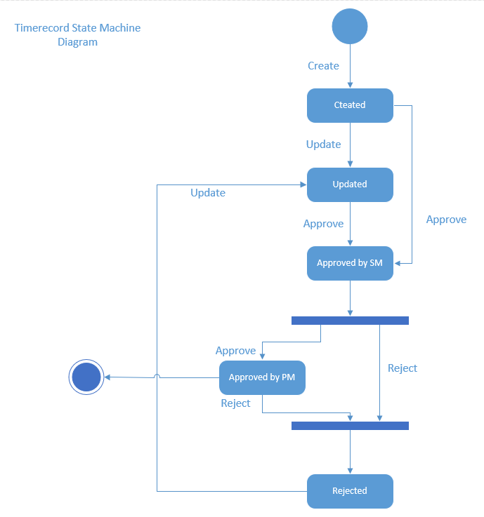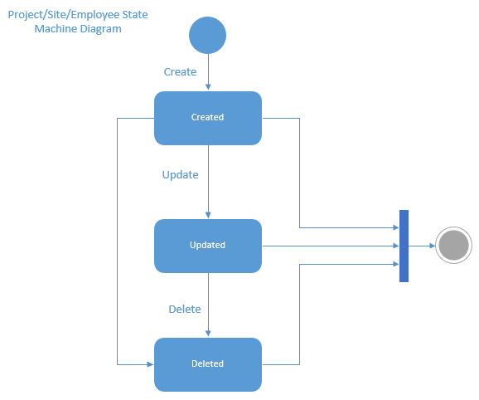

# Communication diagrams

The diagrams show interactions between objects. It helps to create alternative scenarios of interactions if needed.

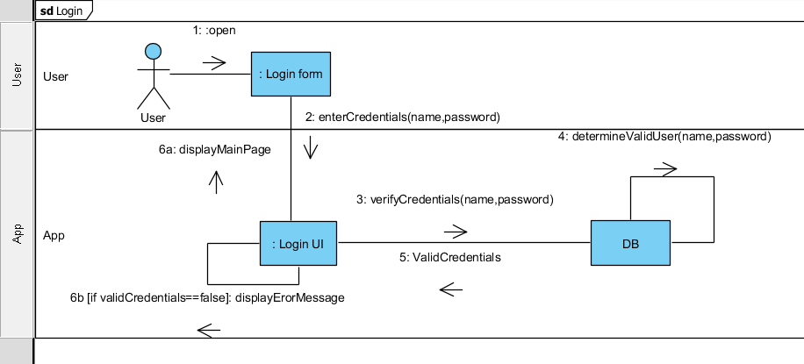

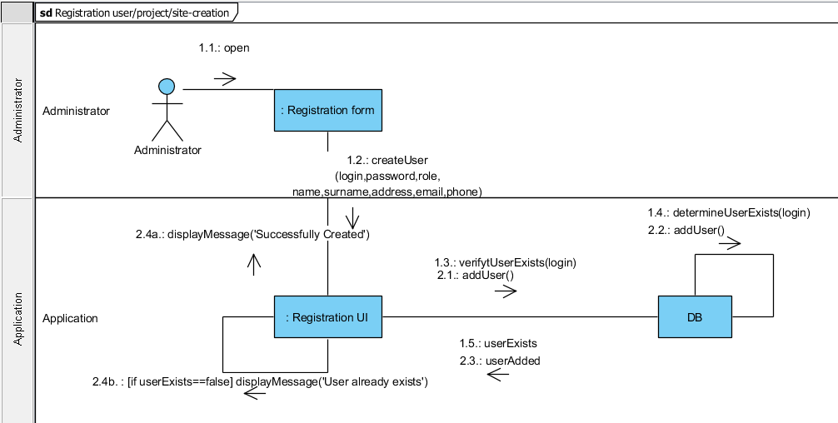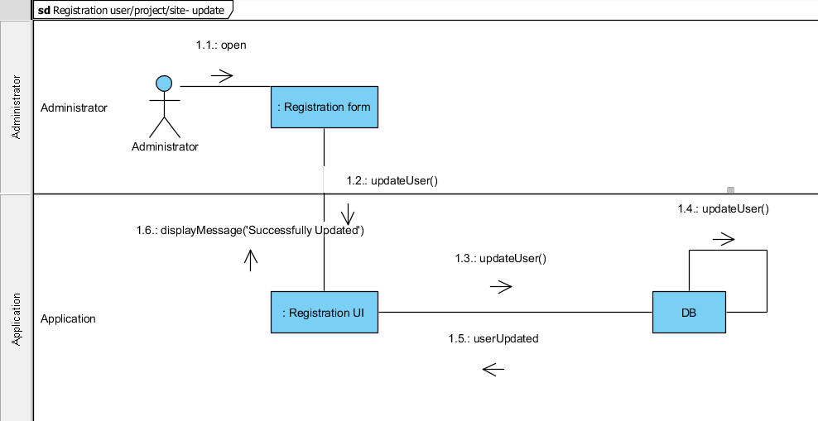

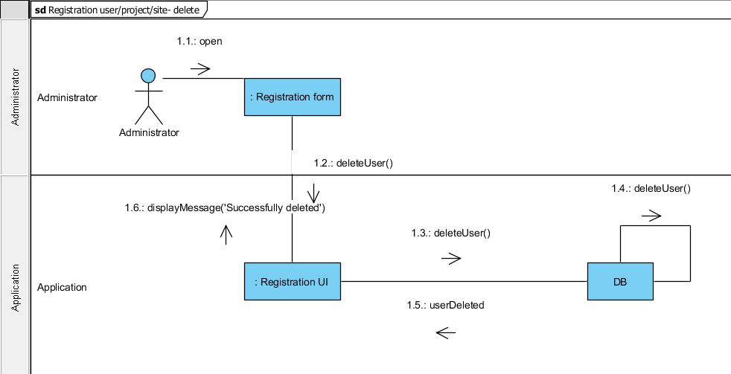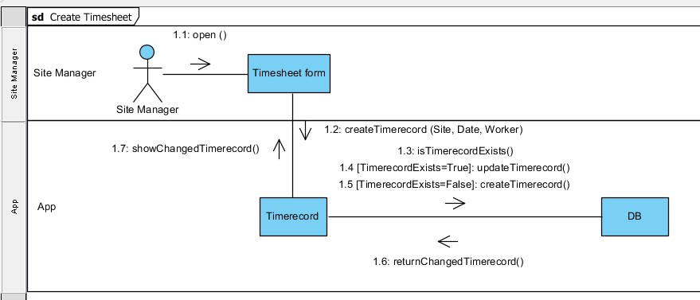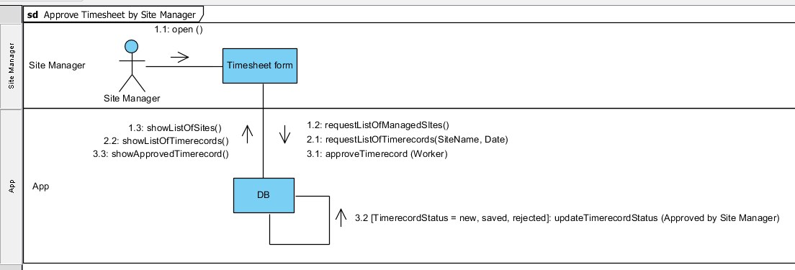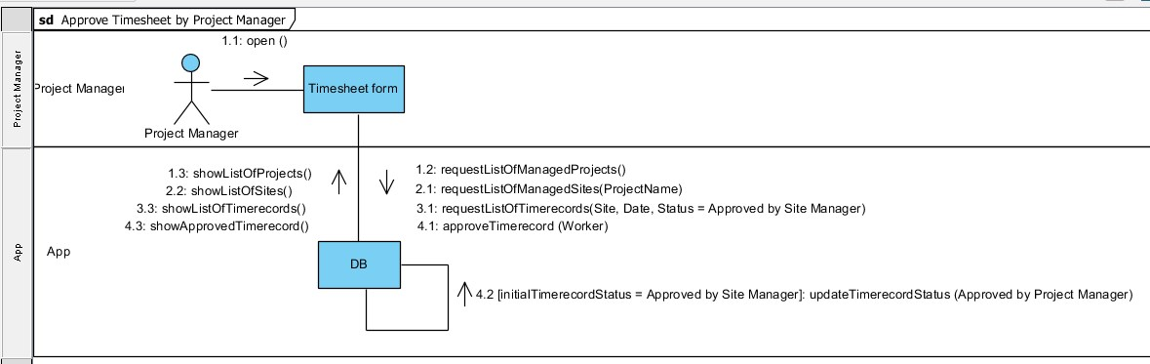

# Project Marking Criteria

|  |  |  |  |
| --- | --- | --- | --- |
| **Marking Criteria** |  |  | **Comment(s):** |
| **Task 1: Introduction and overview of the project** |  |  |  |
| * Introduction * Discussion of the Business Context   + *The business problem is correctly identified* * Project Description   + *A brief description of the project idea and importance and the proposed functions that will be provided by the project.* * Goal and objectives of the project   + *The project’s main goals and objectives have been identified.* * Development Methodology which will be adopted   + *The development methodology to be used have been identified*   + *The motivations behind selecting this methodology have been described*   + *The development methodology steps have been clearly explained* * The target audience and benefit of the information system o *The targeted people that will get benefited from the project have been identified*    + *The benefits of the project have been described*   *(tangible and intangible)* | 1    2    2        2        1    2    2        1    2 |  |  |
| ***Total>>>*** | 15 |  |  |
|  |  |  |  |
| **Task 2: System Requirements Specification** |  |  |  |
| Functional Requirements   * The functional requirements are clearly identified and summarised precisely. * They have been classified as Process Oriented or Information Oriented requirements. | 4      3 |  |  |
| Non Functional Requirements   * The non-functional requirements are clearly identified and summarised precisely. * They have been classified as Operational, Performance, Security or Cultural and Legal requirements. | 4        4 |  |  |
| ***Total>>>*** | 15 |  |  |

|  |  |  |  |
| --- | --- | --- | --- |
|  |  |  |  |
| **Task 3: Functional Model** |  |  |  |
| Use case Diagrams   * The use case diagram should capture all the system functionalities in scope and actors. * *The diagrams analyse the required system correctly* * *The diagrams use correct UML 2.0 notation* | 4    2  2 |  |  |
| Use case Specification   * A specification has been given for each use case * Each specification includes the main sections (use case name, actors, preconditions, post conditions, steps). | 3    3 |  |  |
| Activity Diagram   * Capture all functionality in use cases * *The diagrams use correct UML 2.0 notation* | 3  3 |  |  |
| ***Total>>>*** | 20 |  |  |
|  |  |  |  |
| **Task 4: Object Model** |  |  |  |
| Class Diagrams   * Correct classes have been identified * Attributes and operations are identified for each class * Appropriate relationships are used (Association, multiplicity, generalization) * *The diagrams use correct UML 2.0 notation* | 3  3  3    1 |  |  |
| Object diagrams   * The diagrams are consistent with the class diagram. * *The diagrams use correct UML 2.0 notation.* | 4  1 |  |  |
| ***Total>>>*** | 15 |  |  |
|  |  |  |  |
| **Task 5: Logical Design Model** |  |  |  |
| Sequence Diagrams   * The diagrams are consistent with the use case diagram. * *Capture all possible scenarios identified in use cases* * *The diagrams use correct UML 2.0 notation* | 4    4  1 |  |  |
| State Machines   * The diagrams are consistent with the class diagram. * Capture the states of each class. * *The diagrams use correct UML 2.0 notation* | 3  3  1 |  |  |
| Communication Diagrams   * The diagrams are consistent with the use case diagram and sequence diagrams. * *Capture all possible scenarios identified in use cases*  *The diagrams use correct UML 2.0 notation* | 4    4  1 |  |  |
| ***Total>>>*** | 25 |  |  |
|  |  |  |  |
| **Task 6: Documentation (10 marks)** |  |  |  |
| * The report includes all the required sections: o Cover page o Table of Content   + Introduction and Overview of the project   + Requirement Specification o Functional Model o Object Model o Logical Design Model   + Discussion: briefly describes any lessons learnt during the analysis and design process.   + References: o Appendices (if any)   + Marking Criteria      * *The report is presented to a professional standard with correct language and grammar is used*      * Discussion Section: *includes appropriate lessons learnt with examples*      * *References:* APA referencing style is used correctly | 2                                    2      3      3 |  |  |
| ***Total>>>*** | **10** |  |  |
| **Overall Mark>>>** | **100** |  |  |

# Discussion

Analyzing and designing a system starts from a bunch of requirements to complete and useful Information System. Through out of this process many people with various perspectives play their roles when they need to communicate and understand each other in efficient and optimized way, reducing misunderstanding.

The well-defined framework and standard are very helpful to plan the development of Information Systems through understanding and specifying in detail what is the goal of the system and how the modules of the system work together and implement.

For example, without any technical knowledge, diagrams (like activity diagram and use cases) are easily understood by the client and team members, which helps all of them to speak in "one language" and understand each other.

Besides, various diagrams help the team to make a plan for implementing the system and divide the tasks between each other without any conflict or reworking. For example, class diagram and sequence diagram help the team to better understand the components of the system, how they work together and should be implemented.

# References

Agile Alliance (n.d.) *Kanban.* Retrieved from: https://www.agilealliance.org/glossary/kanban/#q=~(filters~(postType~(~'page~'post~'aa_book~'aa_event_session~'aa_experience_report~'aa_glossary~'aa_research_paper~'aa_video)~tags~(~'kanban))~searchTerm~'~sort~false~sortDirection~'asc~page~1)

[Association of Modern Technologies Professionals](http://www.amtp.am/). (2018). *Software Development Methodologies.* Retrieved from: http://www.itinfo.am/eng/software-development-methodologies/

Bell D. (2004). *The class diagram.* Retrieved from: https://www.ibm.com/developerworks/rational/library/content/RationalEdge/sep04/bell/

IBM knowledge center. (n.d.) *Directed association relationships.* Retrieved from: https://www.ibm.com/support/knowledgecenter/SS8PJ7_9.1.0/com.ibm.xtools.modeler.doc/topics/cdirasn.html

IBM Knowledge center. (n.d.) *Use-case specification outline* Retrieved from: https://www.ibm.com/support/knowledgecenter/en/SSYMRC_4.0.5/com.ibm.rational.rrm.help.doc/topics/r_uc_spec_outline.htmlrational.rrm.help.doc/topics/r_uc_spec_outline.html

National Technology Institute, (2014). *DC304N Object-Oriented Analysis and Design*.

Visual Paradigm. (n.d.) *What is Activity Diagram?* Retrieved from: https://www.visual-paradigm.com/guide/uml-unified-modeling-language/what-is-activity-diagram/

Visual Paradigm. (n.d.) *What is Communication Diagram?* Retrieved from: https://www.visual-paradigm.com/guide/uml-unified-modeling-language/what-is-communication-diagram/

Visual Paradigm. (n.d.) *What is Sequence Diagram?* Retrieved from: https://www.visual-paradigm.com/guide/uml-unified-modeling-language/what-is-sequence-diagram/